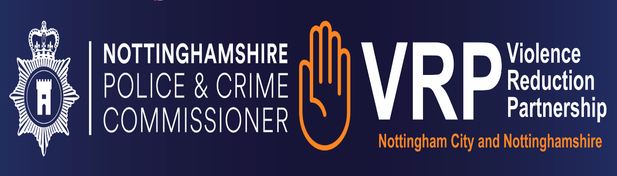

Nottingham VRP/OPCC Youth Projects

Training Pathways Self Assessment Tool

Please use in conjunction with the Training Pathways Framework

Organisation information
Example in red:

Organisation Name: John Smiths Boxing |  |  |  |  |  |  | Number of staff in organisation: | 4
TRAINING PATHWAY FRAMEWORK
Youth Work Qualifications | Staff with no qualifications in Youth Work | Level 1 Certificate in exploring Youth Work (Intro) | Level 2 award  (4 modules) | Level 2  Certificate in Youth Work Practice (5 module + 1) JNC (equivalent to GCSE) | Level 3 Certificate / Dip in Youth Work Practice (equivalent to A’ Level) | List team CPD Training gained, and date gained:
Please indicate the qualifications each member of staff holds: | LR | JH, MJ |  | ZB

Those Working With Young People
Minimum Basic Training

Title | Content | Progress Notes | RAG | VRU Funded Training
Safeguarding:  Child Protection  and Adult Safeguarding | - Knowledge and understanding of own organisations policies and procedures.  - Be able to define the terms of safeguarding and child protection.  - Be aware of keeping yourself and your team safe when working with children and young people.  - Understand the requirements of reporting safeguarding issues.  - Awareness of digital and online safety. |  |  | Introductory Safeguarding Training  Designated Safeguarding Lead Training  Contextual Safeguarding Training
Engaging and Communication | - Understanding the importance of building relationships with young people.  - Professional identity and professional boundaries  - (Being the friendly professional not the professional friend)  - Using effective listening skills.  - Using the digital world for engaging with young people. |  |  | Engagement and Communication Training
Special Educational Needs and Disability Awareness | - Awareness of special educational needs and disabilities.  - Understanding the need to adapt activities for inclusivity to meet the young persons needs. |  |  | Special Education Needs and Disability Awareness Training
Equality, Diversity and Inclusion | - Cultural Awareness and Cultural Competencies.  - Awareness of anti-oppressive practice.  - Awareness and understand different cultures within  - the community including age, gender, LGBTQ+, race religion.  - Awareness of the Unconscious Bias. |  |  | Cultural Competence and Unconscious Bias Training

Title | Content | Progress Notes | RAG | VRU Funded Training
Exploitation Awareness | - Awareness of children and young people and the risks associated with little or no engagement with peers or professionals.  - Exploitation to include sexual exploitation, gangs, drugs, FGM, financial. |  |  | Exploitation Awareness Training
Health, Safety  and Risk Assessment | - Health and Safety Awareness to include behaviour, safe environments and safe activities.  - Mental health and wellbeing awareness of your own self. |  |  | Health, Safety and Risk Assessment Training  Managing Health and Safety Training.  NB: The VRU offers both of the above in one training course.
Working with  Groups and Individuals | - Understanding participation including group work and working with individuals.  - Managing the group work activity.  - Awareness of working with individuals.  - Code of conduct and decision making with young people. |  |  | Engaging Effectively with Groups and Individuals Training
GDPR,  Information Recording, Storing and Sharing | - An understanding of GDPR, data control and sharing protocols. |  |  | GDPR Training.

Recommended Continued Professional Development

Specialist Training

Title | Content | Progress Notes | RAG | VRU Funded Training
ACE (Adverse Childhood Experience) Awareness | - Becoming ACE Aware.  - Impact of Adverse Childhood Experiences.  - Consequences of ACE’s.  - Building and celebrating resilience.
Knife, Gun and  Gang Crime Awareness | - Awareness of the impacts of weapons and criminal engagement/exploitation on young people, families and communities.  - Understanding how young people can become involved and exploited.  - Recognising vulnerabilities and signs.  - Understanding the impact of behaviours on the family and community.  - Understand the local and national frameworks for working with young people involved in youth violence, criminal activity, child criminal exploitation.
Challenging Behaviour and Managing Conflict | - Understand behaviours that challenge.  - How to deal with behaviours that challenge.  - Dealing with conflict management and the impact of behaviours on group activity.  - Managing parental conflict.
Trauma Informed Work | - Understand the effects of trauma.  - Understand the principle concepts of trauma informed practice.  - Understanding the impact of secondary trauma.

Title | Content | Progress Notes | RAG | VRU Funded Training
Detached Youth Work | - Understanding detached and outreach youth work.  - Understanding the needs and requirements to keep young people and those working with young people safe.
Employability | - Supporting young people to develop skills for employability:  - Application form writing.  - CV writing.  - Interview support.  - Building confidence.  - Presentation skills.  - Financial skills.
Substance Misuse | - Awareness of substance misuse including; Illegal drugs, Prescription Medication, Alcohol.  - Where to go and how to ask for help.  - Recognising signs and symptoms and impact of substance misuse.
Mental Health First Aid | - Understanding young people’s mental health and factors that affect wellbeing.  - Skill to spot triggers and signs of mental health issues.  - Understanding and have confidence to support young people in distress.  - Identifying help for young people with their mental health.
Food Hygiene | - Understanding basic food hygiene for preparing and providing food.
Training for Managers and Leaders of Organisations

Management Training

Title | Content | Progress Notes | RAG | VRU Funded Training
Volunteering and the Law | - Understanding and an awareness of managing volunteers.  - Understanding the law, responsibilities and accountability.
GDPR and Data Protection | - Understanding the law around GDPR.  - Consent to use information.  - Holding and sharing personal data.
Planning and Evaluation | - Understanding the importance of planning and evaluating activity including outcomes and outputs.  - Identifying different models that are suitable for the activities and programmes being delivered.  - Understanding evaluation and the different methods of evaluation, including types of evaluation.
Governance | - Understanding the legal requirements for Governance.  - Understanding the responsibilities for Governance Boards.  - Understanding Governance Board roles individual responsibilities.

Title | Content | Progress Notes | RAG | VRU Funded Training
Partnership and  Multi-Agency approach to work with young people and the community | - Identifying the benefits of partnership working.  - Development of partnerships.  - Development of partnership agreements or service level agreements.  - Developing outcomes that can benefit all organisations involved in the partnership.  - Understanding which partners will provide the best outcomes during programmes and or projects.  - Identifying collaboration opportunities for the benefit of young people and the community.
Managing Health and Safety | - Managing Health and Safety including buildings, staff, volunteers and visitors.  - Risk Assessment processes.  - Identifying and understanding own organisations health and safety policy.  - Providing requirements for first aid provision.  - Understanding and acting on the need for reporting accidents.
Safer Recruitment | - Understanding the need for safer recruitment.  - Awareness of DBS and how to use this.  - Recruiting staff or volunteers who have criminal convictions.

